Hotel Management System(Urban)

**2023-2024**

**BCA-SEM-6**

**KAMANI SCIENCE COLLAGE-AMRELI**

**Developed By :**

**SEJPAL MANSI P.**

**SENJALIYA NISHA R.**

Hotel Management System (Urban)

2023-2024

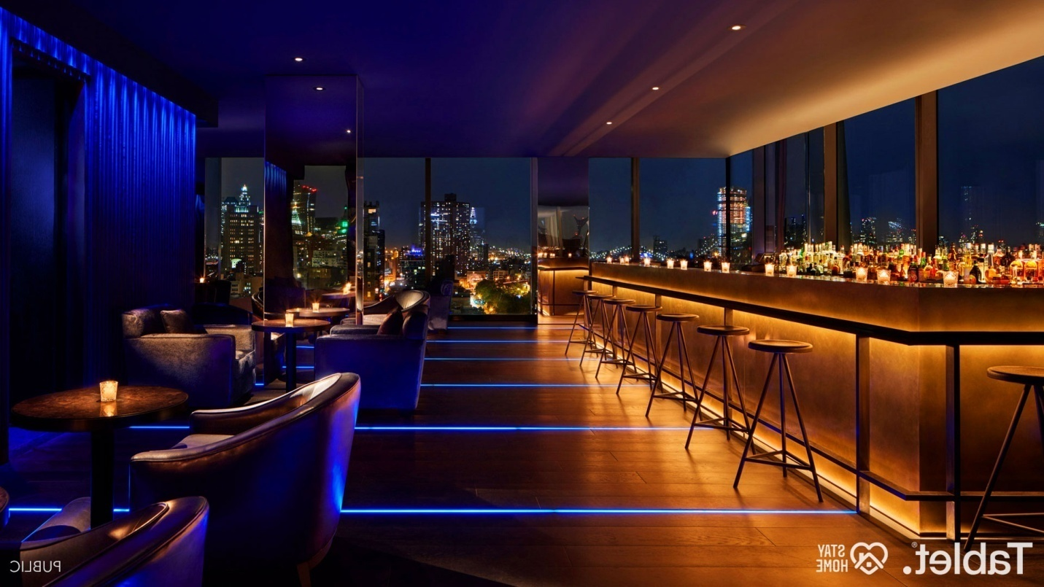

A Project Report On

**HOTEL MANAGEMENT SYSTEM**



**Kamani Science And Prataprai Arts College, Amreli.**

Developed By

**BCA SEM - 5**

**Sejpal Mansi P. (ENROLLMENT NO : 00320321787)**

**Senjaliya Nisha R. (ENROLLMENT NO : 00320321789)**

Guided By

**Pro. Nilesh Parghi**

**Submitted in partial Fulfillment Of the Requirement for the Award of The Degree of Computer Application (BCA).**

Year Of Submission

**2023-24**

**Saurashtra University-Rajkot.**



**Preface**

The main objective of any computer science student is to get practical knowledge as possible. Being able to have a practical knowledge by developing a project is a lifetime experience. As practical knowledge is important as theoretical knowledge I am thankful of having a project.

Through the development of the project I had a great experience of various strategies that can be applied in development of the project. This project is the stepping stone for our career.

I am pleased to present this project report. Proper case has been taken while organizing the report so that it is easy to comprehend. Also, various software engineering concepts have been implemented.

**Acknowledgement**

We are student of BCA sem-6 Studying in the Kamani Science College, Amreli. We Thanks to the entire person who has given their support in shaping of the system.

we thanks Pro. Nilesh Parghi for giving us guidance and Cooperation in understanding the system. We also thanks them for their unconditional help in making of this project.

We have great deal of gratitude towards our head of department who encourage us in taking up this activity. We thanks all faculties and administrative staffs of the institute.

Thanks to all !!

Sejpal Mansi P.

Senjaliya Nisha R.

**Certificate**

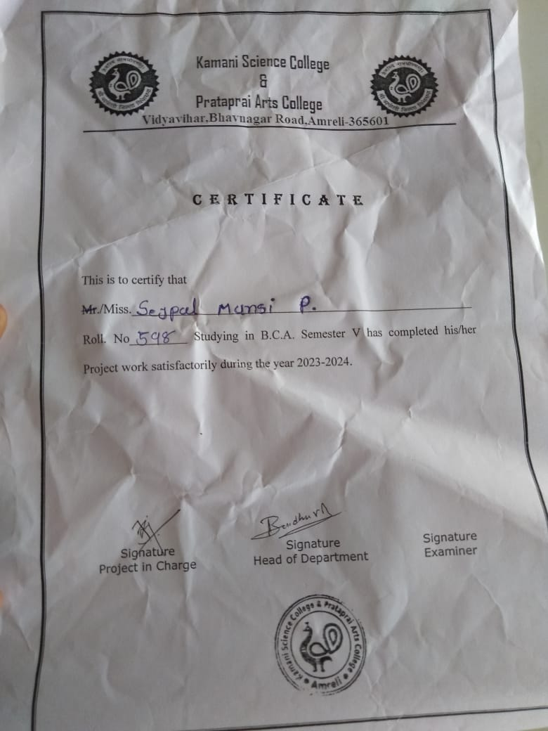

**Index**

|  |  |  |
| --- | --- | --- |
| No. | Title | Page No. |
| 1. | Introduction | 7 |
| 2. | Project Profile | 8 |
| 3. | Hardware Requirements | 9 |
| 4. | Software Requirements | 9 |
| 5. | Requirement Specification | 10 |
| 6. | Problem Definition | 10 |
| 7. | Project Planning & Scheduling | 11 |
| 8. | System Analysis | 12 |
| 9. | Feasibility Study | 13 |
| 10. | Project Page Structure | 16 |
| 11. | Data Dictionary | 17 |
| 12. | Data Flow Diagram | 21 |
| 13. | E-R Diagram | 24 |
| 14. | Use-Case Diagram | 25 |
| 15. | Activity Diagram | 26 |
| 16. | Time-Line Chart | 28 |
| 17. | Screenshots | 29 |
| 18. | Future Scops | 41 |
| 19. | References | 41 |

**Introduction**

Hotel Management is a software system where the management of entire hotel is computerized. Our system name is Urban Hotel. Our system is standalone system. We manage all the activities related to the hotel like room booking, room management, customer details, employee management, and billing of rooms.

In out project provide us to handle customer detail, reservation detail, booking detail and billing details the reservation process of reserving rooms for the customer,cancelling the reserved rooms ,update booking etc..

In short we can say ‘Hotel Management System’ is a very efficient project which helps in daily basis work of booking detail & billing.

We provide functionalities like:

* Check in
* Check out
* View occupied room
* Add new rooms
* Scanning faces of customers
* Cancelling room
* Sending mail
* Sending SMS
* Employee QR code generator

.

**Project Profile**

|  |  |
| --- | --- |
| * Project Name : | Hotel Management System(Urban) |
| * Developed By : | Mansi sejpal & Nisha Senjaliya | |
| * Front End Tool : | Python | |
| * Back End Tool : | MySql | |
| * Operating System : | Microsoft Windows 10pro | |
| * Computer System : | Pentium-IV or Higher ,RAM-256 MB | |
| * Project Detail : | This system is a about management of hotel in this system we can manage all rooms, bookings, customer-details, billing and employee-management. | |
| * Compilation Time : | Approx 3-4 Month | |
| * Guidance By : | Pro. Nilesh Parghi | |
| * Submitted By : | Saurashtra University, Rajkot. | |

**Hardware Requirement**

* 512+ MB of RAM
* Multimedia Keyboard And Mouse
* 1.0+ GHz Processor
* Monitor
* 32X CD Drive

**Software Requirement**

* Operating System: Microsoft windows

XP & Windows 10pro

* Front End Tools : Python
* Back End Tools : MySQL
* Documentation Tools : Microsoft Word

**Requirement Specification**

* MySQL RDBMS used to maintain the all concerned data.
* Reservation management
* Billing and invoice
* Staff/employee management

**Problem Definition**

* Maintain rooms
* Maintain Payment
* Maintain billing
* Maintain Customer List
* Maintain employes
* Maintain Security

**Project Planning & Scheduling**

Project planning is an aspect of project management , which are comprises of various processes .we have a many ideas of asp.net projects but we make some differentiate that’s why we have to choose Hotel Management in Python. Because python is now trending in AI(Artificial Intelligence).

Using this standalone system we can book a rooms, view occupied rooms, update booking, details, delete/cancelling the booking, management of employes, billing and invoice etc..

The project start with:-

* Enter 1 – Login
* Enter 2 – Customer detail
* Enter 3 – Customer booking
* Enter 4 – View customers
* Enter 5 – Bill and Invoice
* Enter 6 – Employees management

We are so glad that this work have been assigned to us, yet we haven’t done this work before Nilesh sir our guider.

**System Analysis**

System analysis is the process of identification of objectives and requirements, evaluation of alternative solutions and recommendation for a more feasible solution. In other words, system analysis is the step by step process of gathering, recording and interpreting facts. The main aim of analysis is to determine problem areas and to take solutions to reduce or eliminate them.

* System analysis itself breaks into two stages:
* Preliminary analysis
* Detailed analysis

During analysis, data are collected from the available files, decision points and transactions of the systems using various tools like Data Flow Diagram (DFD).

**Feasibility Study**

A purpose of feasibility study is to check out the possibility of a computerized solution to the organization’s observed problem before very much money that has been spent on.

A feasibility study is carried out to select the best system that meets performance requirements. Only by spending the time to evaluate the feasibility do I reduce the chances for extreme embarrassment at later stage of the system project.

For the complete feasibility study I need to concentrate on following area:

* There are Three types of it :

1. Technical

2. Operational

3. Economical

* Technical :

Technical feasibility considers whether the desired project can be completed within the framework of available technology. As our project was website designing, this was not much of a problem, as many advanced web-editing tools are available.

* Operational :

Operational feasibility was done to assure that the product that would be developed would be used. Since a cards and gifts has to have a website of its own sooner or later, that wasn’t much of a problem.

* Economical :

Our Commercial Website is Economically Feasible Because. We have developed this website only for one time. Only future enhancement is required on the other hand every client can view our site any time or many time as per their requirement. So the future economical expenses are null. So we can say that this website is totally economically feasible.

**Project Page Structure**

* Admin Side :
* Login
* Home
* Dashboard
* Customers
* Registered customers
* Rooms
* Employes
* billing
* invoice
* booking
* logout

**Project Page Structure**

* Admin Side :

admin Side

Manage

booking

Add

booking

Add

Employes

e

Manage

customer

Add customers

Dashboard

Login

Manage billing and invoice

Manage employes

Logout

**Data Dictionary**

The data Dictionary is a set of table. MySQL uses it to maintain information about his own database.

* **Data dictionary contains the following information:**
* Name of the table of database .
* User information such as priviliges.
* Name and data-type of all columns in database table.

**DataBase Name:**  hoteldb.sql

1. **login :-**

|  |  |  |  |
| --- | --- | --- | --- |
| Field | Type | Null | Key |
| id | **int(222)** | **No** | **Primary** |
| username | **varchar(222)** | **No** | **-** |
| password | **varchar(222)** | **No** | **-** |

* This table is used to store login information.

**2.customers:-**

* This table is used to store customer information.

|  |  |  |  |
| --- | --- | --- | --- |
| Field | Type | Null | Key |
| refno | **int(222)** | **No** | **Primary** |
| name | **varchar(6)** | **No** | **-** |

|  |  |  |  |
| --- | --- | --- | --- |
| gender | int(222) | No | primary |
| postcode | **int(222)** | **No** | **-** |
| mobile | **varchar(222)** | **No** | **-** |
| email | **varchar(222)** | **No** | **-** |
| nationality | **varchar(222)** | **No** | **-** |
| idproof | **varchar(222)** | **No** | **-** |
| idnumber | **int(222)** | **No** | **-** |
| address | **varchar(222)** | **No** | **-** |

**3.Roombooking :-**

* This table is used to store room booking information.

|  |  |  |  |
| --- | --- | --- | --- |
| Field | Type | Null | Key |
| id | **int(11)** | **No** | **primary** |
| Cust_cont | **int(11)** | **No** | **Foreign key** |
| Check-in | **date** | **No** | **-** |
| Check-out | **date** | **No** | **-** |
| Room_no | **int** | **No** | **Foreign key** |
| Room_availbl | **varchar** | **No** | **-** |
| meal | **varchar** | **No** | **-** |
| noofdays | **int** | **No** | **-** |

**4.Roomdetail:-**

* This table is used to store roomdetail information.

|  |  |  |  |
| --- | --- | --- | --- |
| Field | Type | Null | key |
| Room_no | **int(222)** | **No** | **primary** |
| Room_type | **varchar(222)** | **No** | **-** |
| floor | **Int(11)** | **No** | **-** |

**5.employe:-**

* This table is used to store employe information.

|  |  |  |  |
| --- | --- | --- | --- |
| Field | Type | Null | Key |
| id | **int(222)** | **No** | **Primary** |
| empnm | **varchar(222)** | **No** | **-** |
| empdept | **varchar(222)** | **No** | **-** |
| empgen | **varchar(222)** | **No** | **-** |
| empaddr | **varchar(222)** | **No** | **-** |
| empmail | **varchar(222)** | **No** | **-** |
| empid | **int** | **No** | **Foreign key** |

**6.empdetails :-**

* This table is used to store employe department information.

|  |  |  |  |
| --- | --- | --- | --- |
| Fiels | Type | Null | Key |
| Emp_id | **int(222)** | **No** | **primary** |
| empcon | **int** | **No** | **-** |
| empdept | **varchar(222)** | **No** | **-** |

**7.bill :-**

* This table is used to store users bill information.

|  |  |  |  |
| --- | --- | --- | --- |
| Field | Type | Null | Key |
| Bill_no | **Int(222)** | **No** | **Primary** |
| cname | **Varchar(222)** | **No** | **-** |
| contact | **Varchar(222)** | **No** | **-** |
| datetime | **Date** | **No** | **-** |
| roomtype | **Varchar(222)** | **No** | **-** |
| roomno | **int** | **No** | **Foreign key** |
| cost | **Float** | **No** | **-** |

**Data Flow Diagram**

The DFD gives brief idea on how the designed system is working. It also suggests to us the type of users who using this system and the process involved in the system.

Represent Data Flow

Represent a form



Represent a Data Table

Represent a Decision

Represent a Process

**Context Level Diagram**

* **Context level Diagram**

**Online Food Ordering System**

**USER**

**ADMIN**

0.0

**Response**

**Response**

**Request For**

**Registration**

**Request To Join**

* **1st level Diagram for**

**View restaurant details**

**online Food Ordering System**

**restaurant details**

1.1

**Admin Login**

**Order**

**dish**

**View your orders**

**Get Dish**

**Order Message**

**Cart**

**Add restaurant**

**Delete restaurant**

**Know restaurant cancellation**

**cance;Cancellation**

**Registration**

**User Login**

**ADMIN**

**USER**

1.2

1.4

1.3

1.6

1.5

1.10

1.7

**View user list**

1.8

1.9

1.12

**View dish**

**Product**

1.13

1.11

**View**

**dish**

* **E-R Diagram**

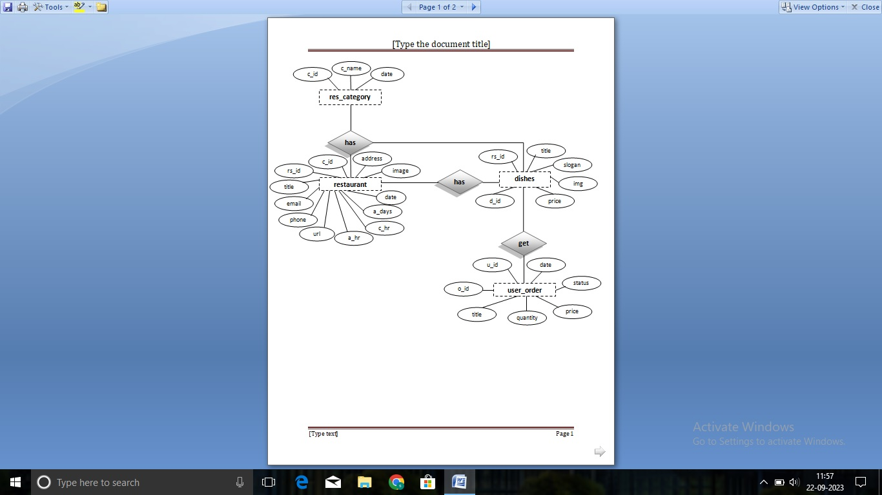

* **Use - Case Diagram**

**Admin**

**Activity Diagram**

* **Client Side**

**Login**

**Check Id ?**

**&**

InValid

Valid

**Logout**

**Add To**

**Cart**

**Order**

**dish**

**Change**

**Password**

**Create**

**Account**

* **Admin Side**

**Login**

**Check Id ?**

**&**

InValid

Valid

**Logout**

**Update/**

**delete**

**orders**

**Add/delete**

**dish**

**Add/delete**

**restaurant**

**Create**

**Account**

**Time Line Chart**

**Online Food Ordering System**

**Screenshots**

* **User Side:--**
* **Registration Page:-**

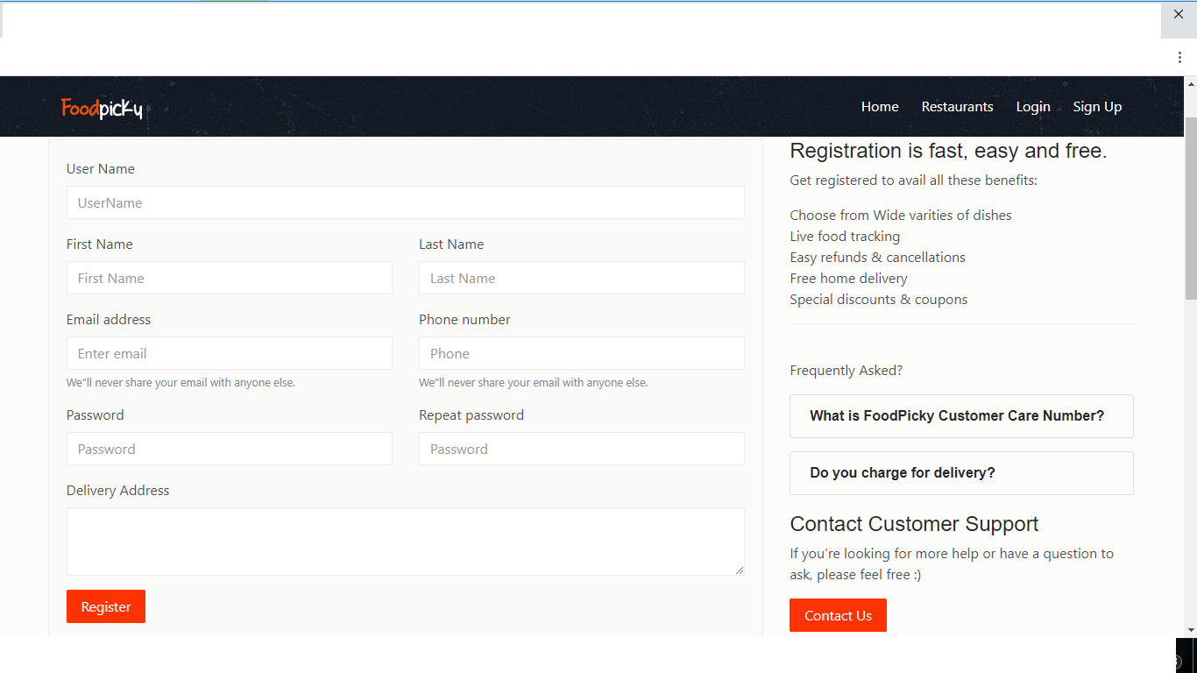

* **Login Page:--**

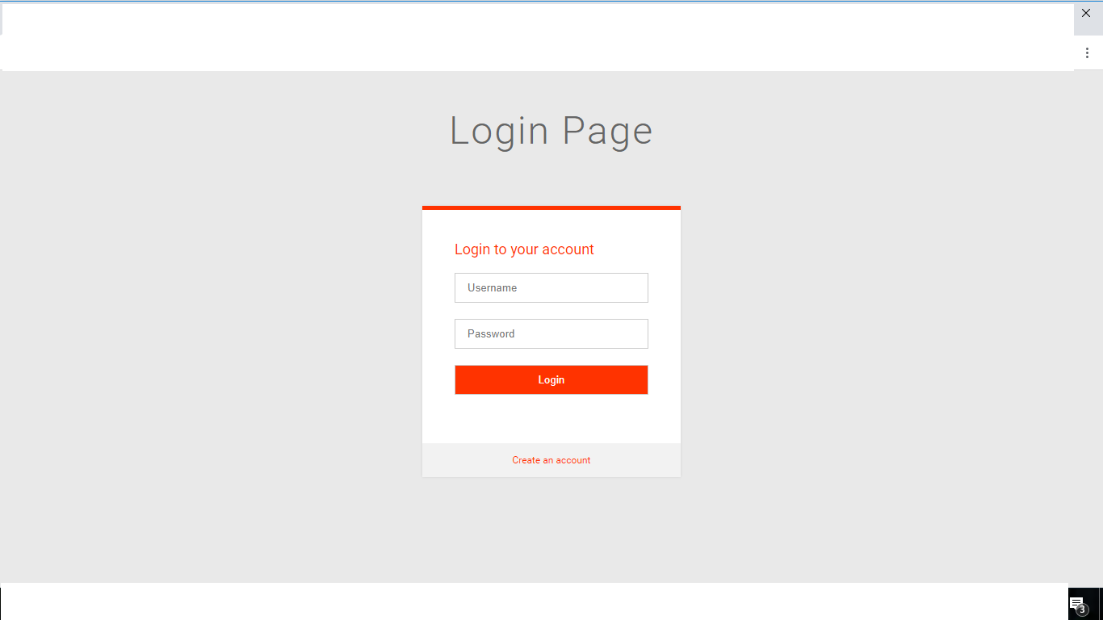

* **Home Page:-**

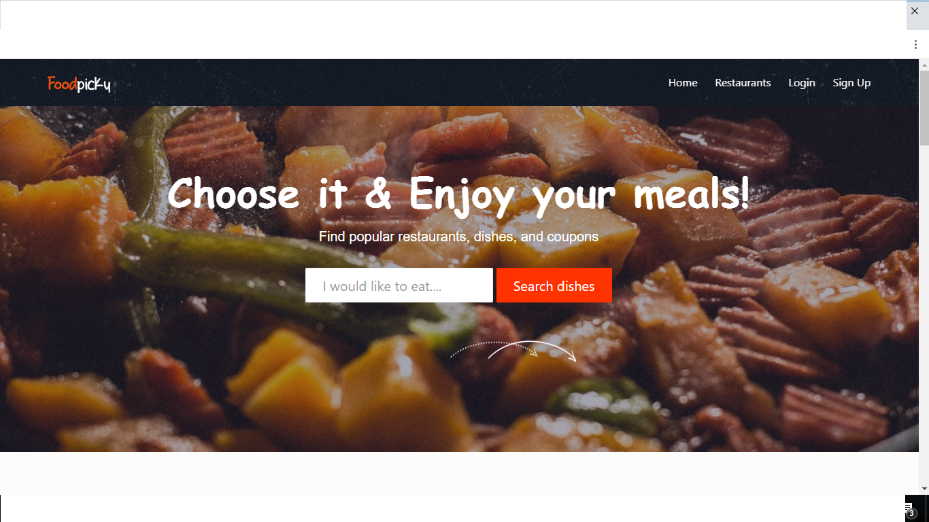

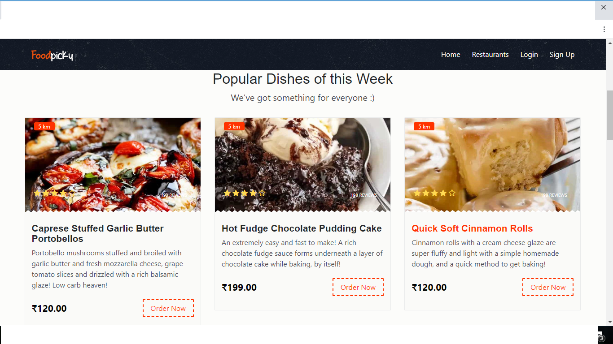

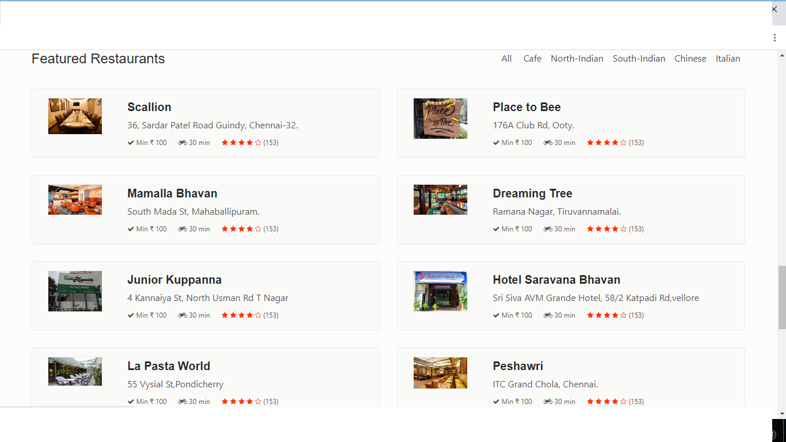

* **Restaurants Page :-**

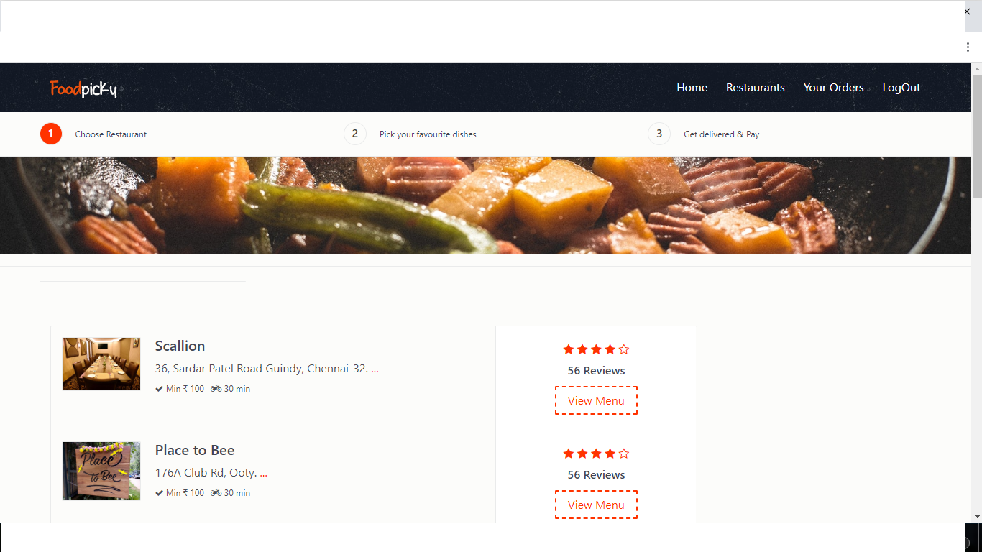

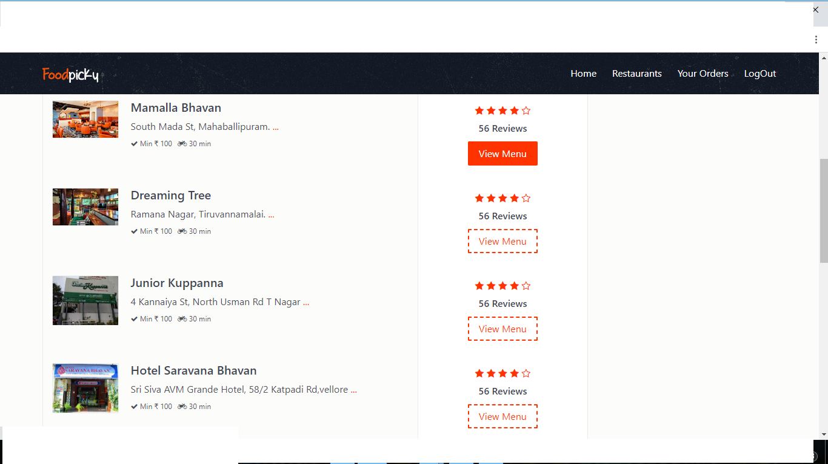

* **Dishes Page :-**

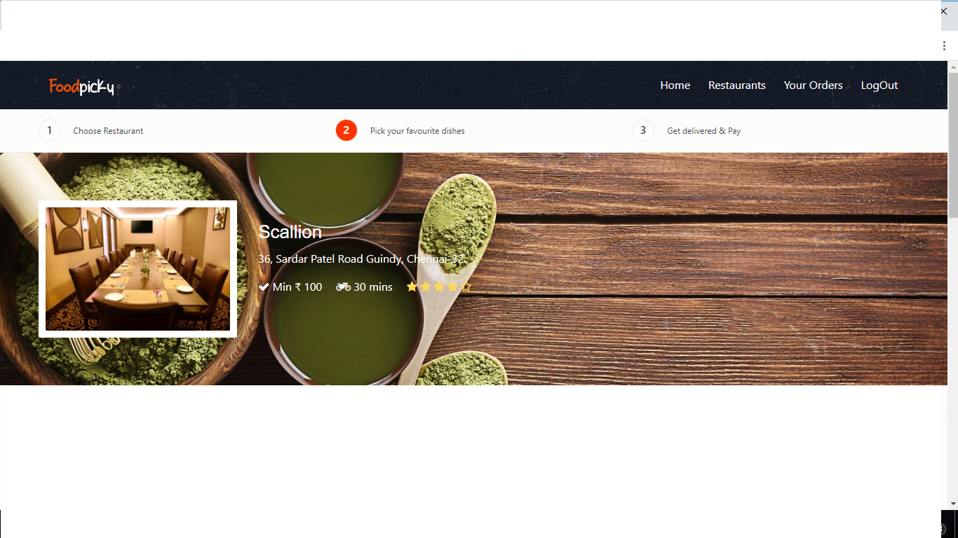

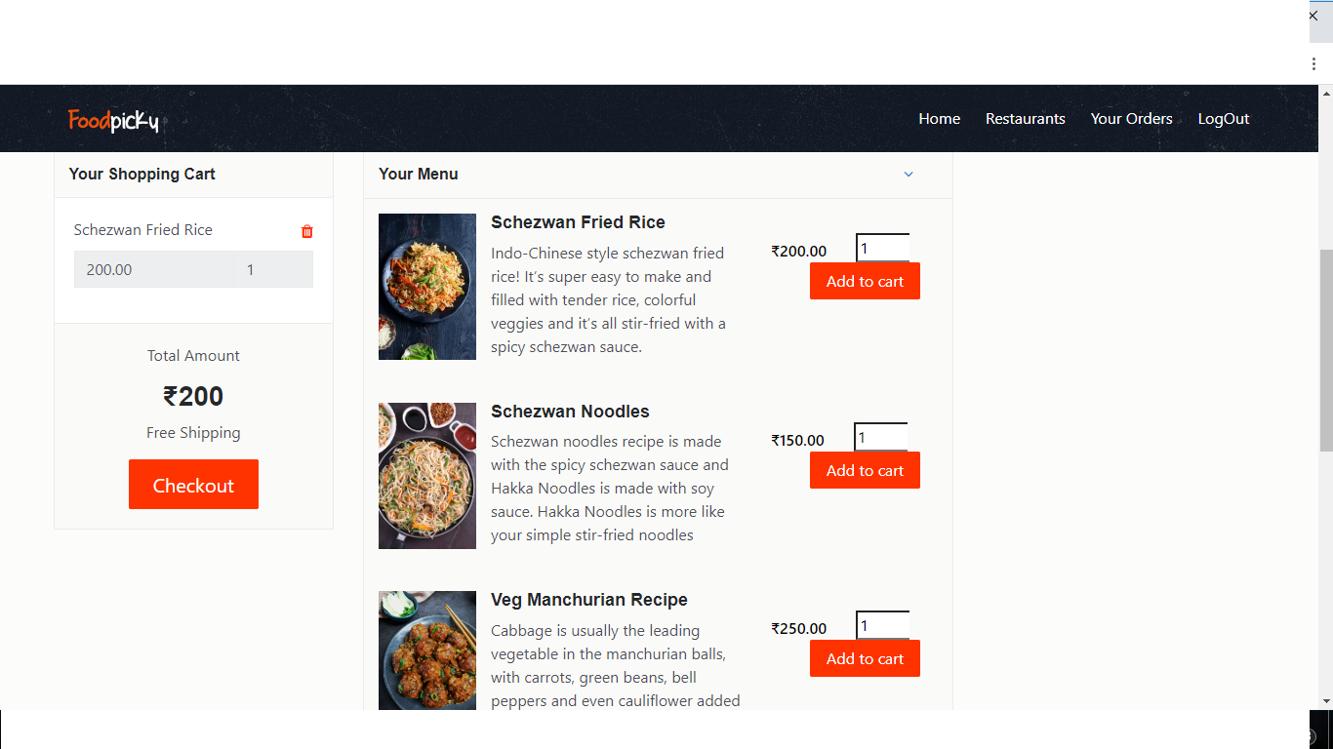

* **Checkout Page :-**

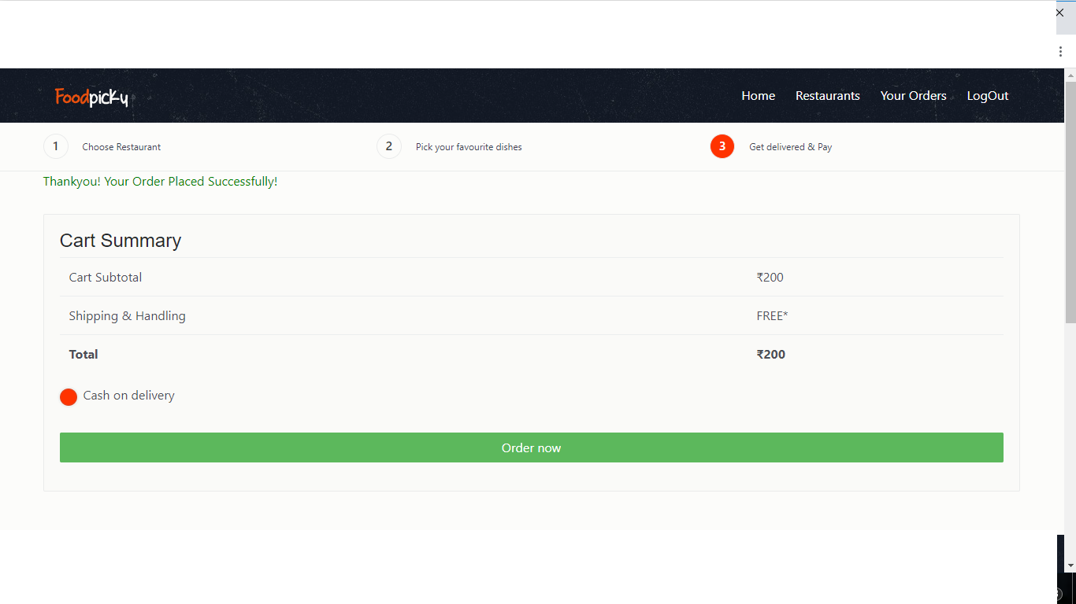

* **Your Orders Page:-**

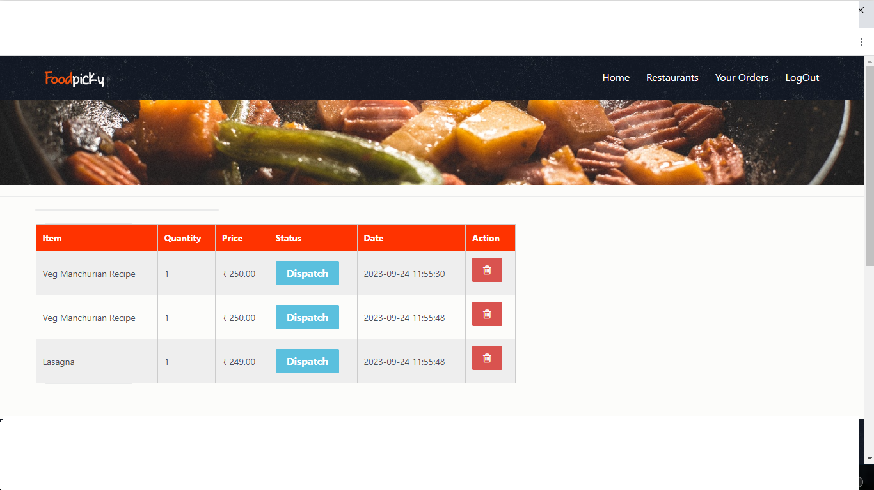

* **Footer :-**

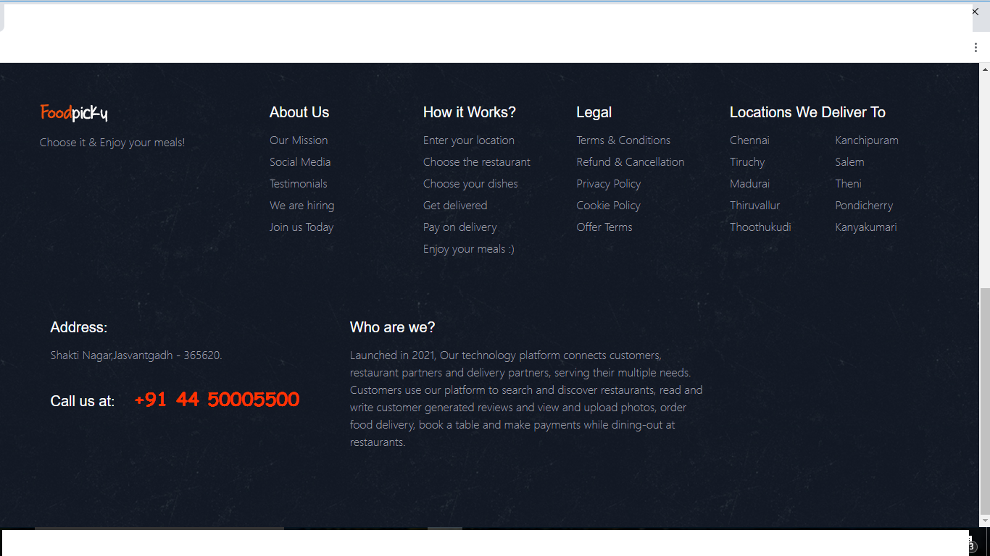

**Screenshots**

* **Admin Side:--**
* **Login Page :--**

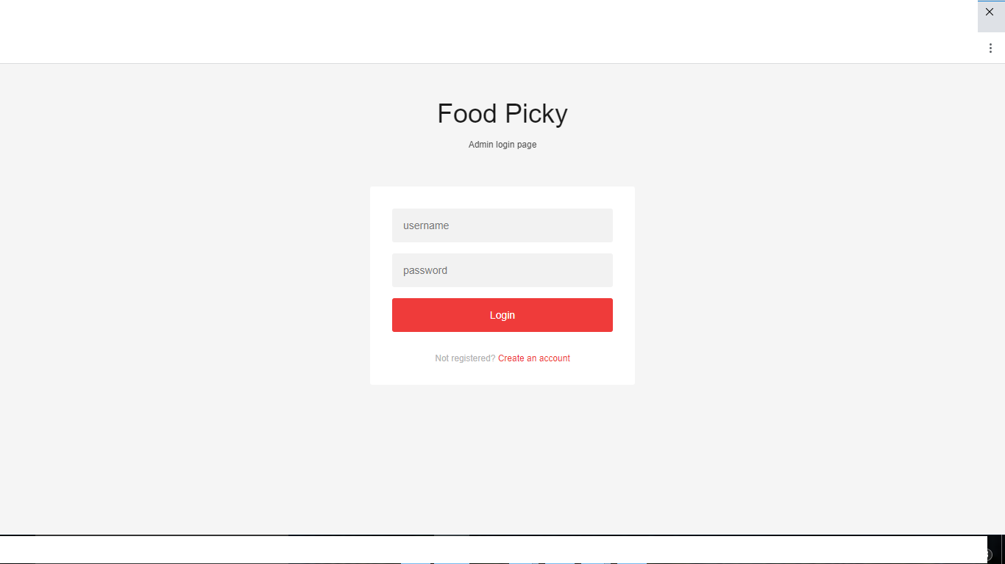

* **Registration Page :--**

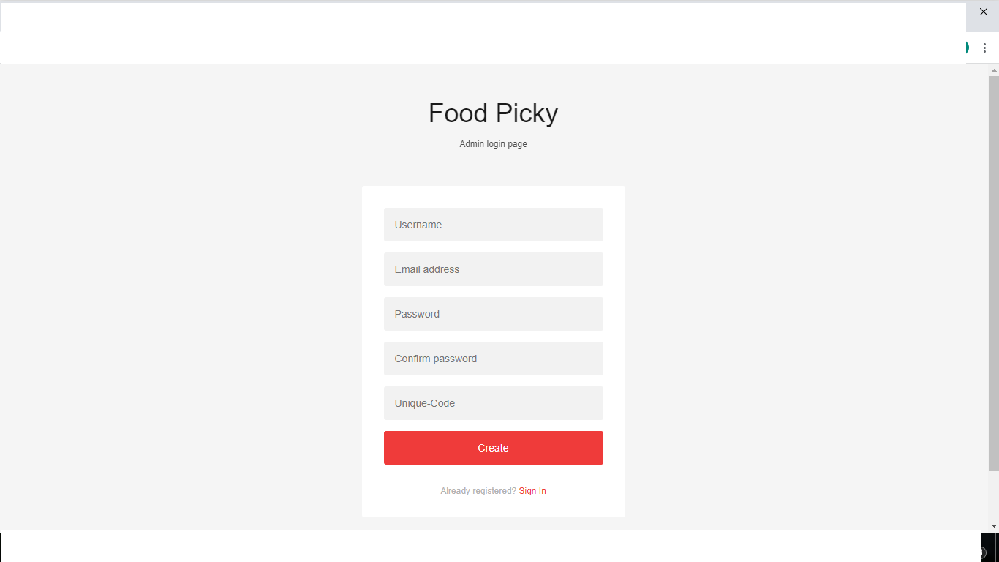

* **Dashboard Page :--**

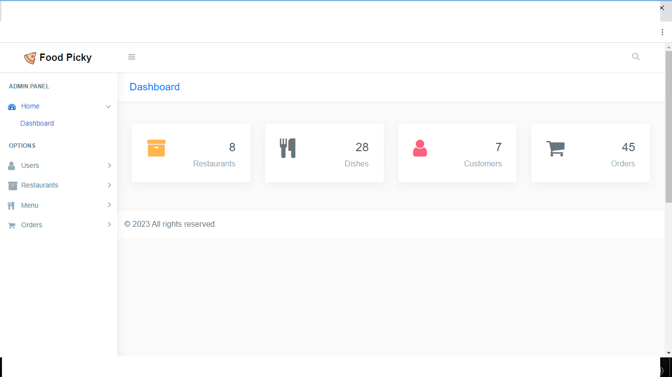

* **All User Page :--**

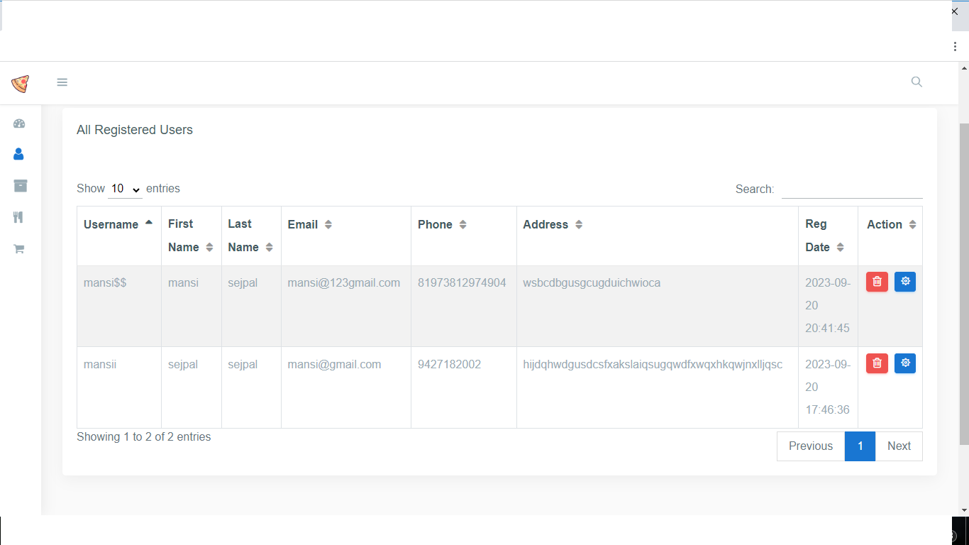

* **Add User Page :--**

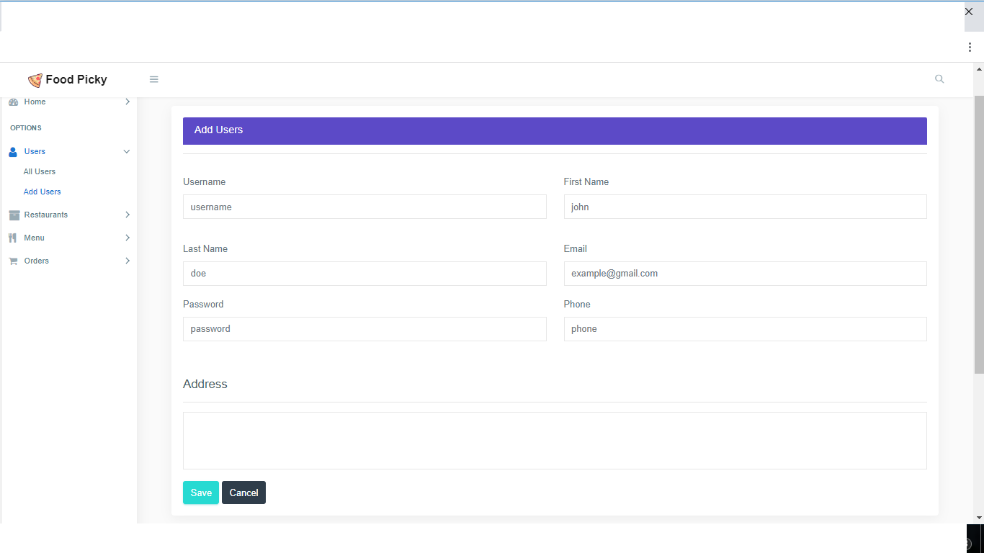

* **All Restaurant Page :--**

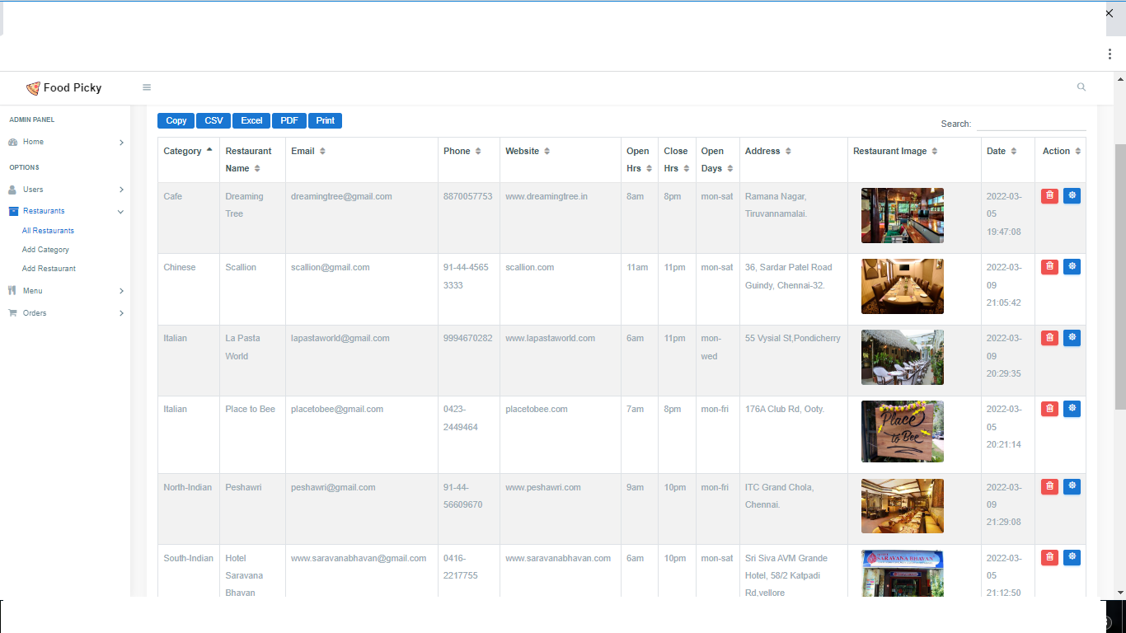

* **Add Category Page :--**

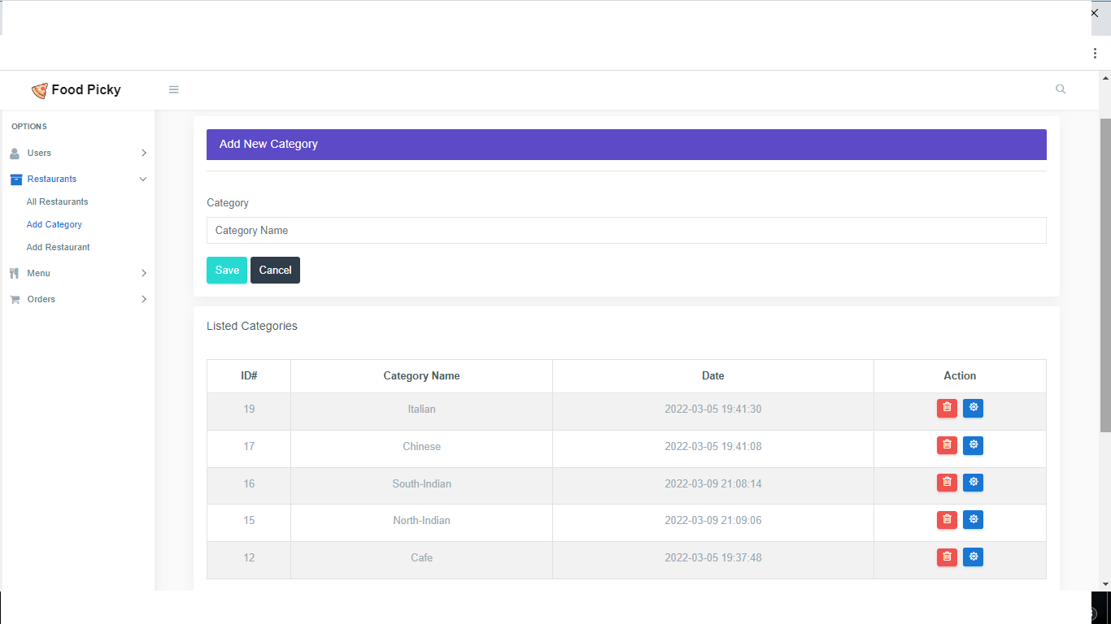

* **Add Restaurant Page :--**

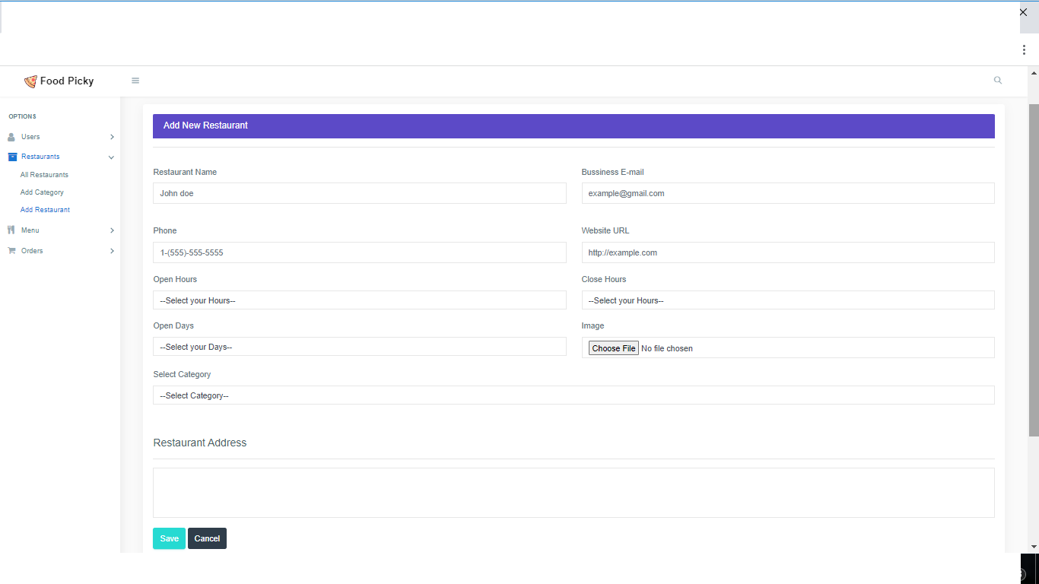

* **All Menus Page :--**

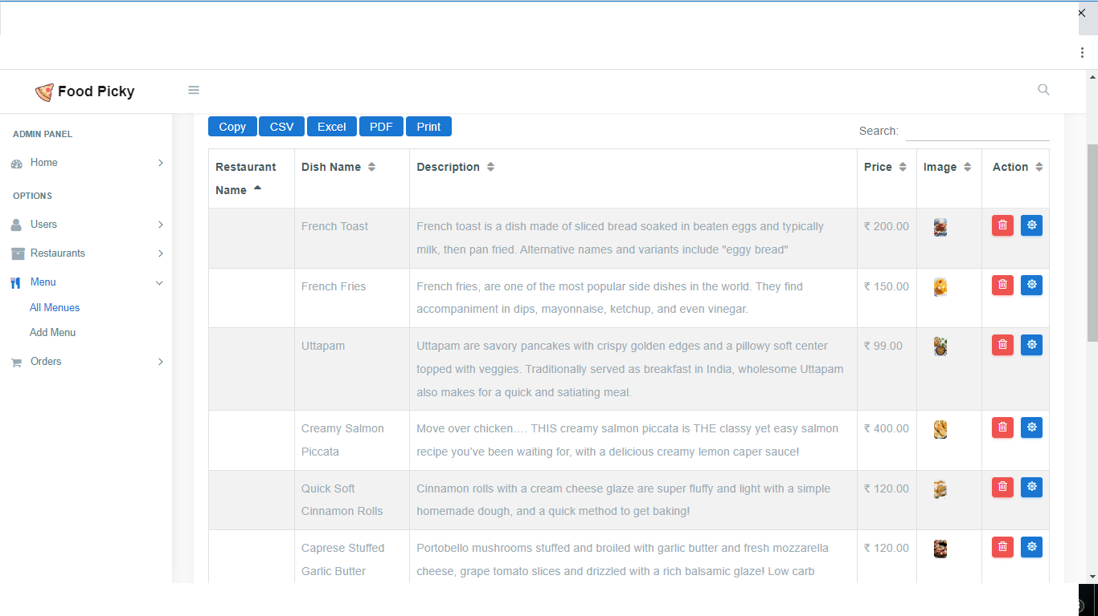

* **Add Menus page :--**

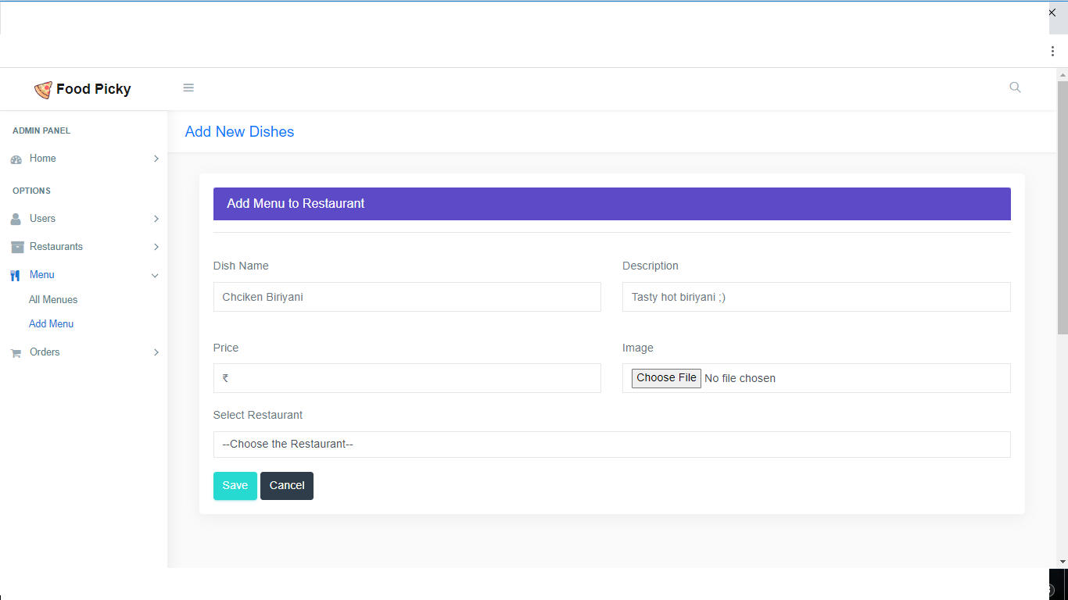

* **All Orders page :--**

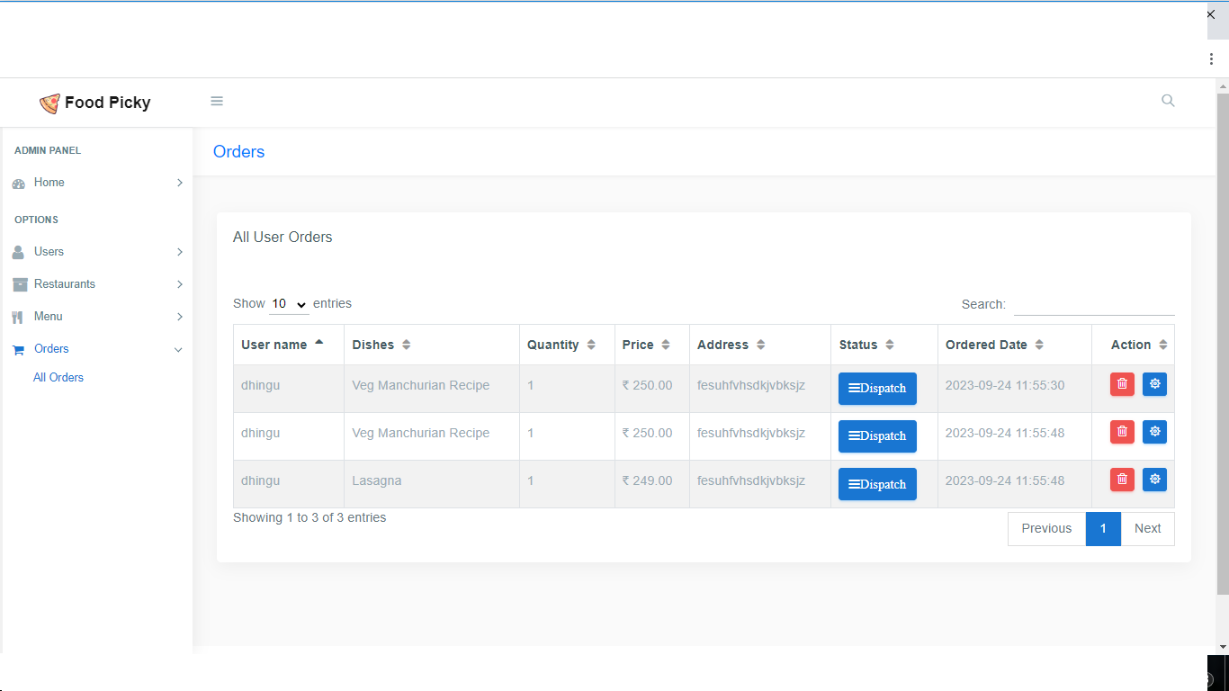

**Future Scope**

The future scope of this website can add more functionality like more security and privacy settings. We will also provide online payment in future scope.

**References**

1. W3Schools

2. Stack Overflow

3. Our Staff

4. [www.google.com](http://www.google.com)